JUMP RIGHT IN
TONAL REGISTER BOOK 1 PATTERNS

1A1 = Unit 1, Section A, Criterion 1
(UnitSectionCriterion)

SKILL LEVEL ORGANIZATION

A/O = Aural/Oral (units 1, 4, 7, 10, 15)
VA = Verbal Association (units 2, 5, 8, 11, 16)
PS = Partial Synthesis (units 6, 17, 20)
SA-r = Symbolic Association-reading (units 12, 21)
SA-w = Symbolic Association-writing (unit 13)
CS-r = Composite Synthesis-reading (unit 19)
G-v = Generalization-verbal (unit 9)
G-s = Generalization-symbolic (unit 18)
C/I-v = Creativity/Improvisation-verbal (unit 3, 14)

JUMP RIGHT IN TONAL REGISTER BOOK 1 PATTERNS
1A1: A/O Sing tonal sequence and class patterns in D major using “bum.”
Do mi | so mi do | so do mi
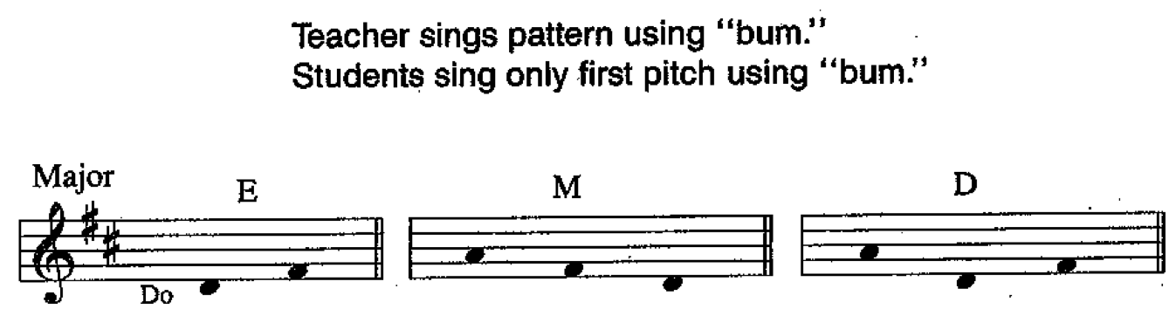

1A2: A/O Sing tonal sequence and class patterns in D major using “bum.” So do | so re so | ti so re
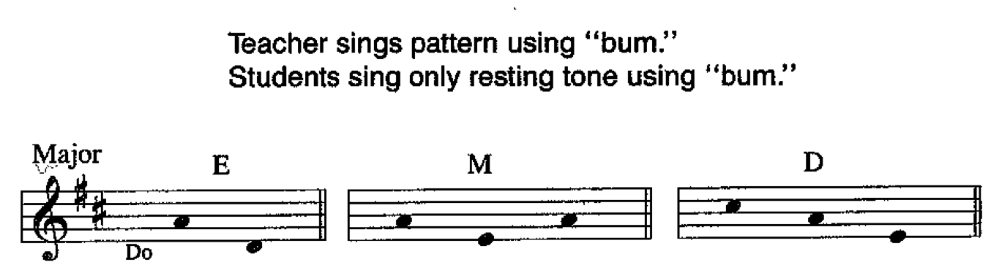

1A3: A/O Sing tonal sequence and class patterns in D major using “bum.” Do mi so | so mi so | do mi do
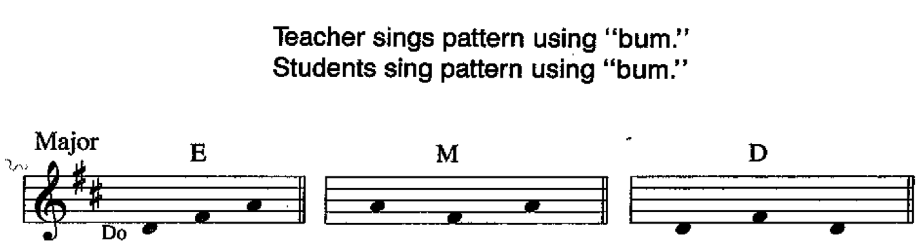

1B1: A/O Sing tonal sequence and class patterns in D minor using “bum.” Do la mi | Mi si | Mi ti si
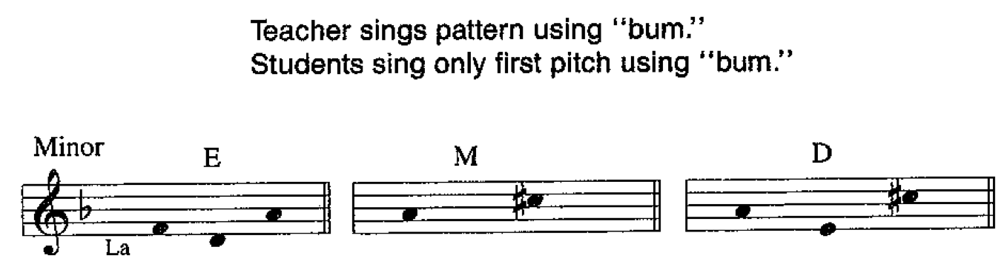

1B2: A/O Sing tonal sequence and class patterns in D minor using “bum.” Si mi | la mi do | do mi
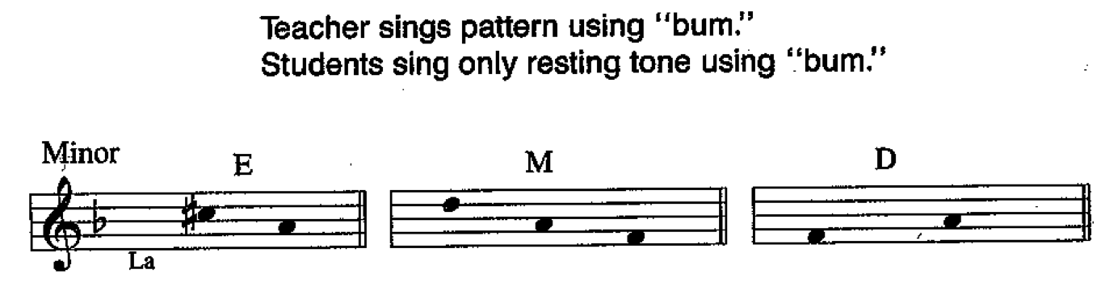

1B3: A/O Sing tonal sequence and class patterns in D minor using “bum.” Mi do mi | ti si mi | la do mi
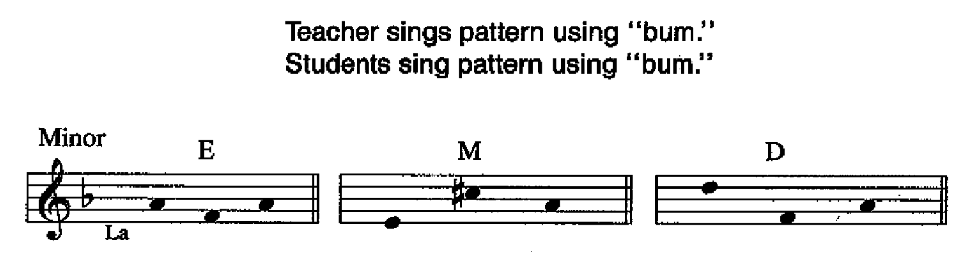

2A1: VA Sing tonal sequence and class patterns in F major using tonal syllables. Do mi so | so re so | so mi do
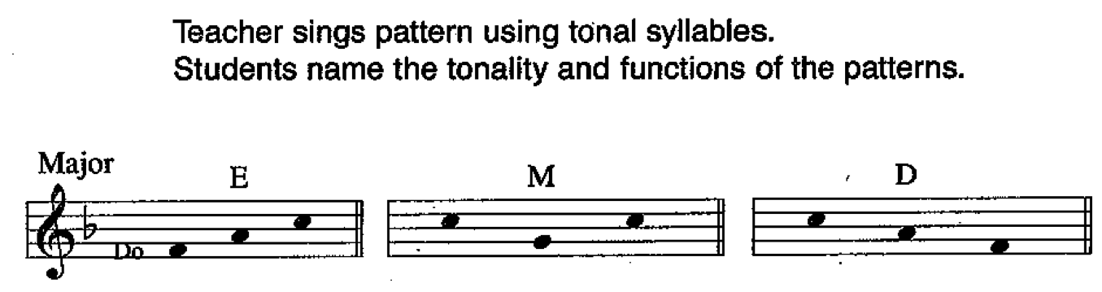

2A2: VA Sing tonal sequence and class patterns in D minor using tonal syllables. Do la mi | ti si mi | do mi
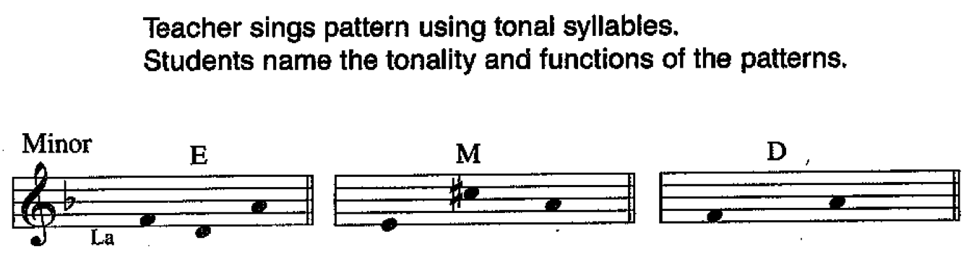

2B1: VA Sing tonal sequence and class patterns in D major using tonal syllables. Do mi | so mi do | so do mi
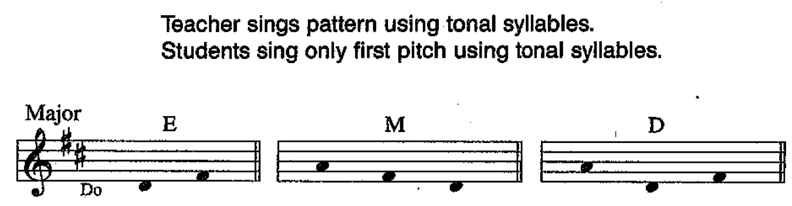

2B2: VA Sing tonal sequence and class patterns in D major using tonal syllables. So mi | so re so | ti mi re
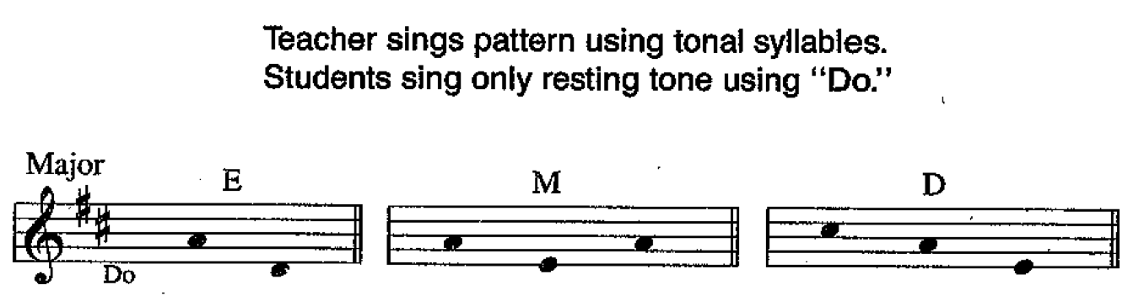

2B3: VA Sing tonal sequence and class patterns in D major using tonal syllables. Do mi so | so mi so | do mi do
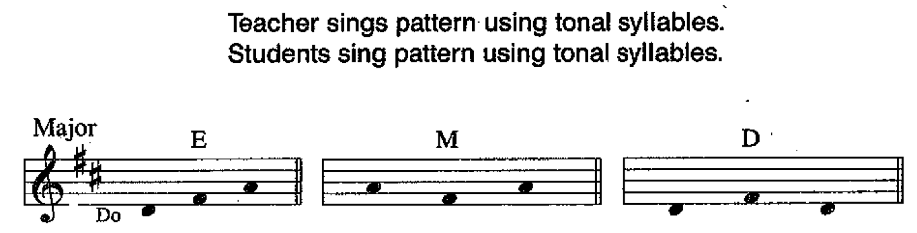

2C1: VA Sing tonal sequence and class patterns in D minor using tonal syllables. Do la mi | mi si | mi ti si
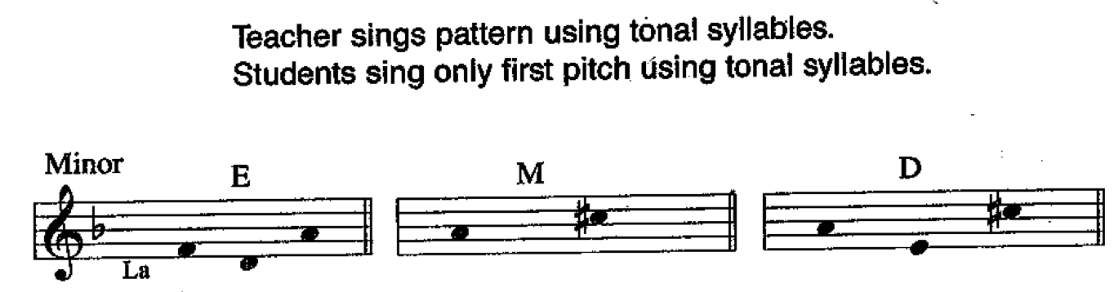

2C2: VA Sing tonal sequence and class patterns in D minor using tonal syllables. Si mi | la mi do | do mi
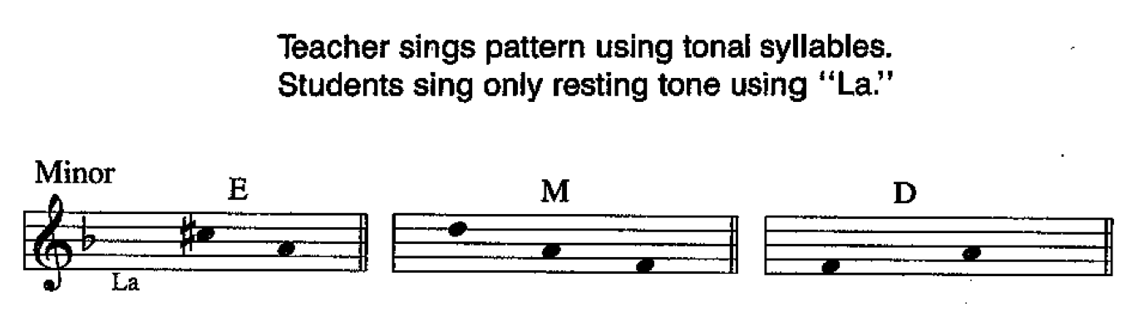

2C3: VA Sing tonal sequence and class patterns in D minor using tonal syllables. Mi do mi | ti si mi | la do mi
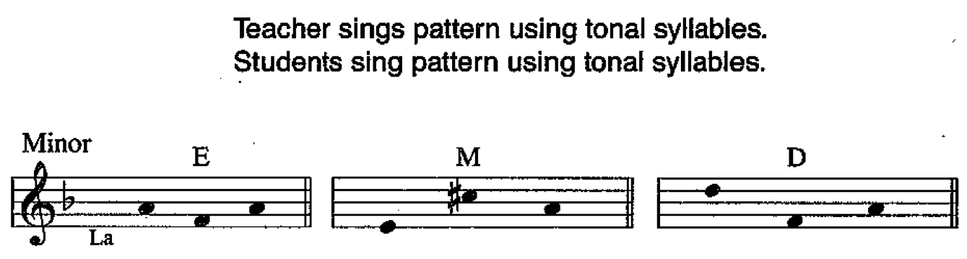

3A1: C/I-v Sing tonal sequence and class patterns in F major using tonal syllables. Mi so | mi do mi | so do mi
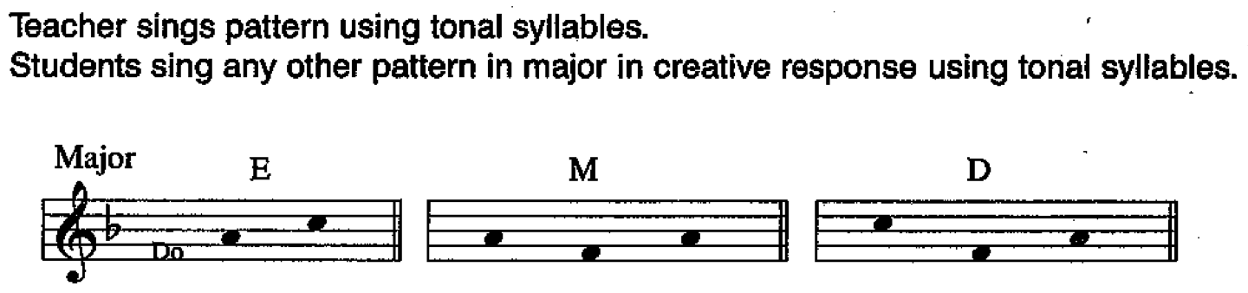

3A2: C/I-v Sing tonal sequence and class patterns in D minor using tonal syllables. La mi la | la mi | la mi la
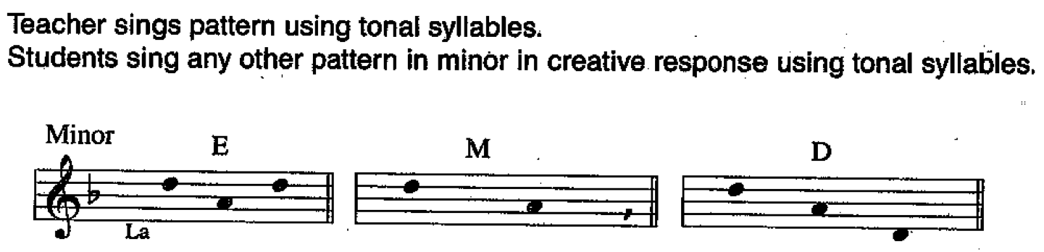

3B1: C/I-v Sing tonal sequence and class patterns in D major using tonal syllables. Re ti mi | do mi do | re fa so ti
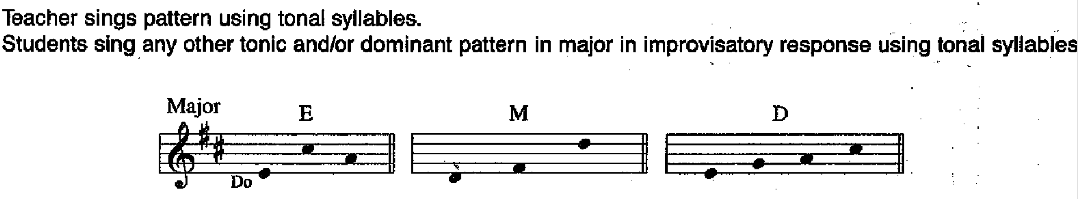

3B2: C/I-v Sing tonal sequence and class patterns in B minor using tonal syllables. Mi si ti | mi la do | do la do
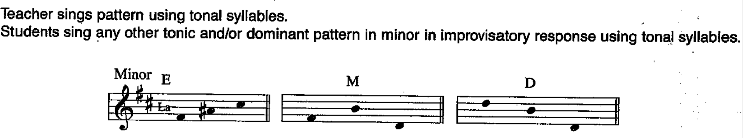

4A1: A/O Sing tonal sequence and class patterns in Bb major using “bum.” Re ti | do mi so | re ti so
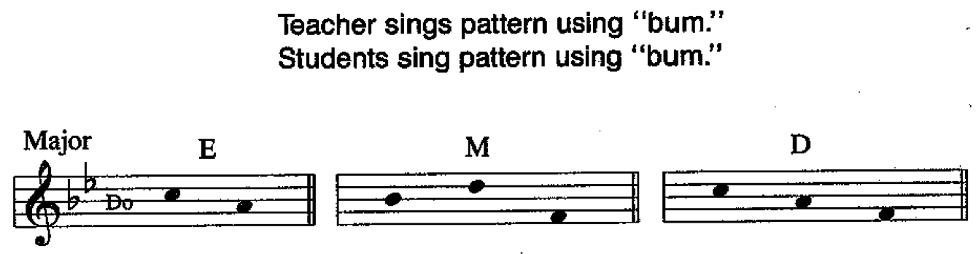

4A2: A/O Sing tonal sequence and class patterns in Bb major using “bum.” Mi so mi | mi do so
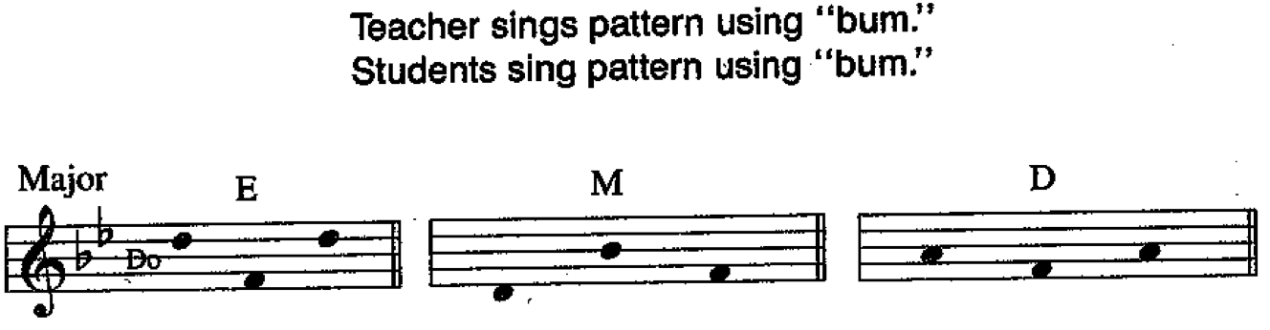

4B1: A/O Sing tonal sequence and class patterns in D minor using “bum.” Si ti mi | ti mi si | la la do
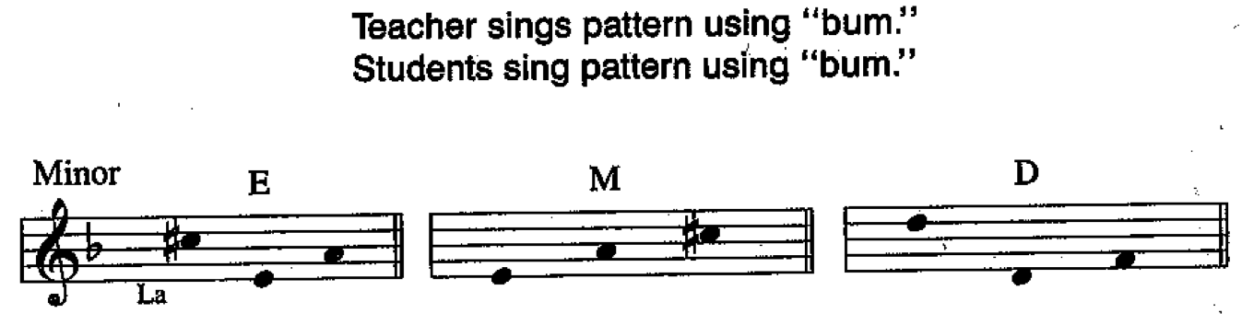

4B2: A/O Sing tonal sequence and class patterns in D minor using “bum.” La la la | la do la | la la mi
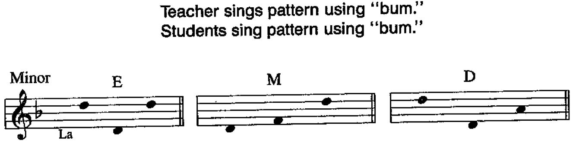

5A1: VA Sing tonal sequence and class patterns in G major using tonal syllables. Re ti | so ti so | ti re fa so
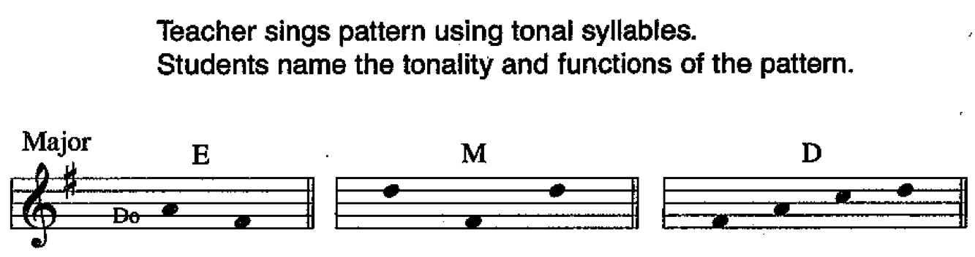

5A2: VA Sing tonal sequence and class patterns in G minor using tonal syllables. Mi mi do | ti mi ti | mi mi do
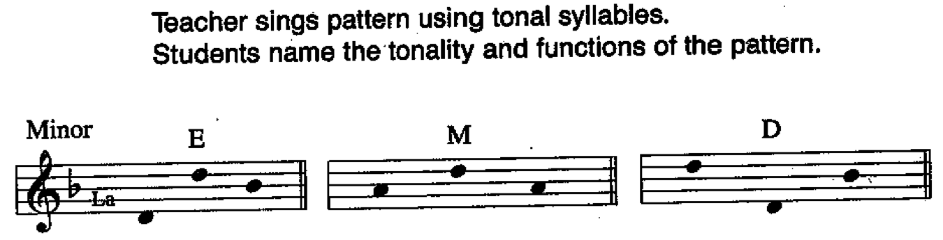

5B1: VA Sing tonal sequence and class patterns in Bb major using tonal syllables. Re ti | do mi so | re ti so
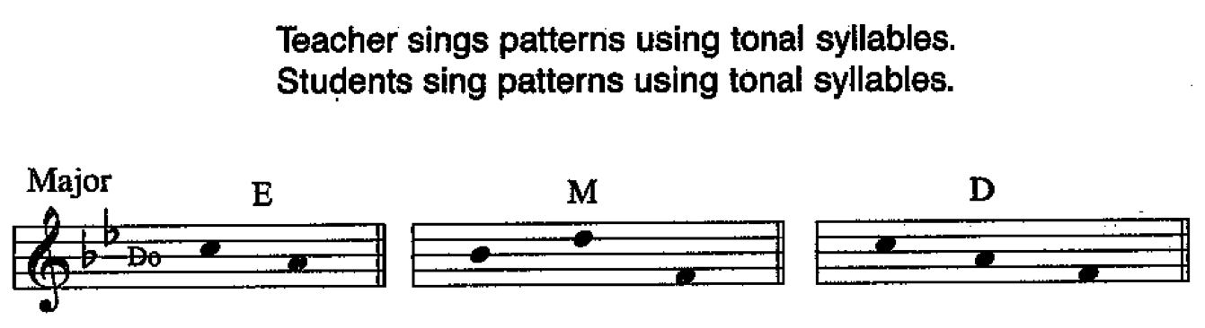

5B2: VA Sing tonal sequence and class patterns in Bb major using tonal syllables. Mi so mi | Mi do so | ti so ti
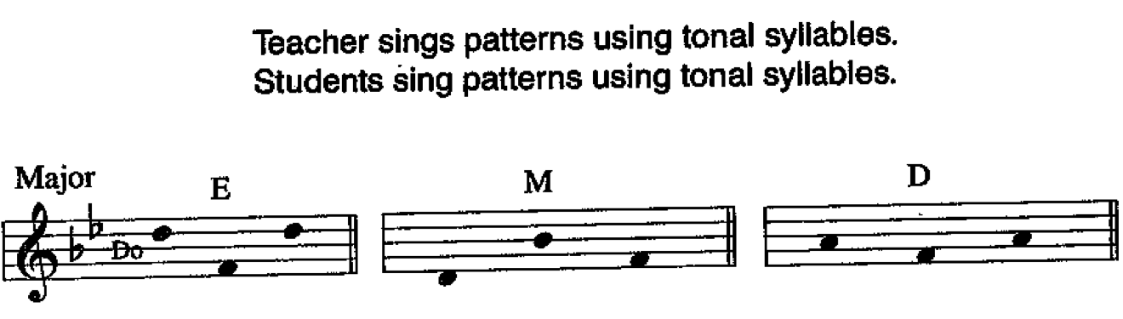

5C1: VA Sing tonal sequence and class patterns in D minor using tonal syllables. Si ti mi | ti mi si | la la do
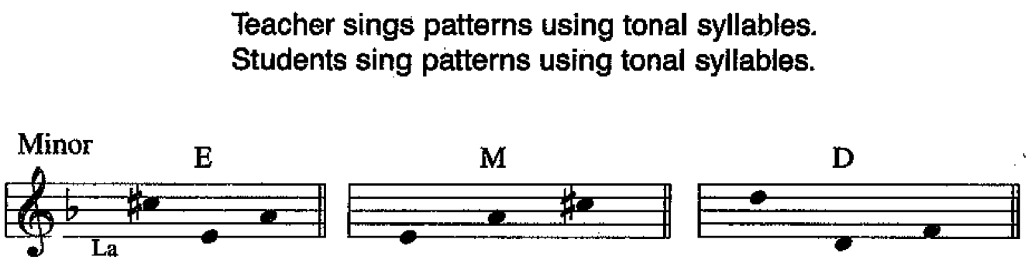

5C2: VA Sing tonal sequence and class patterns in D minor using tonal syllables. La la la | la do la | La la mi
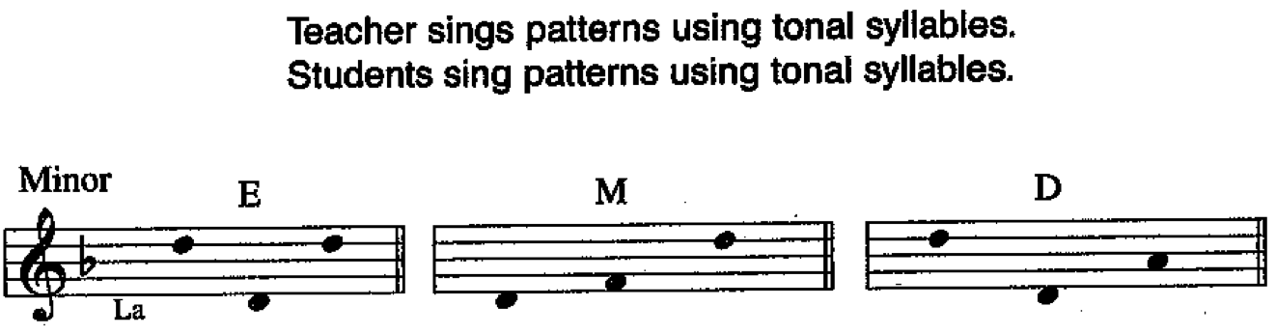

6A1: PS Do not sing tonal sequence or class patterns.
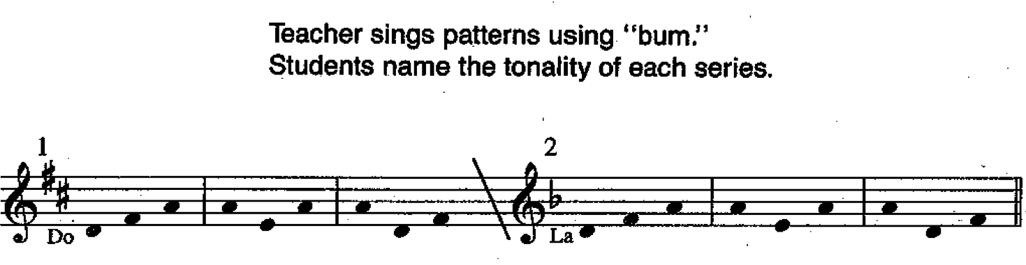

6A2: PS Do not sing tonal sequence or class patterns.
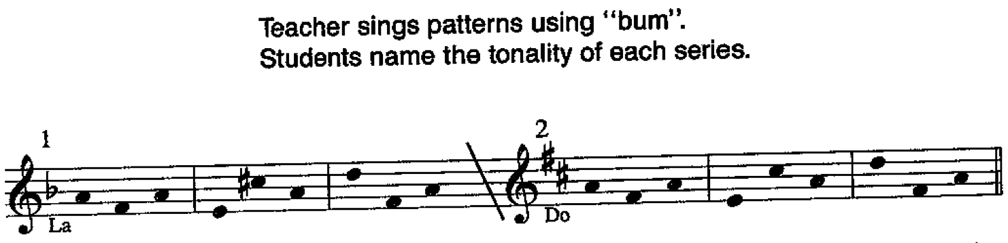

7A1: A/O Sing tonal sequence and class patterns in C major using “bum.” La fa la - so do | la do fa - do so mi | do la fa – do mi do
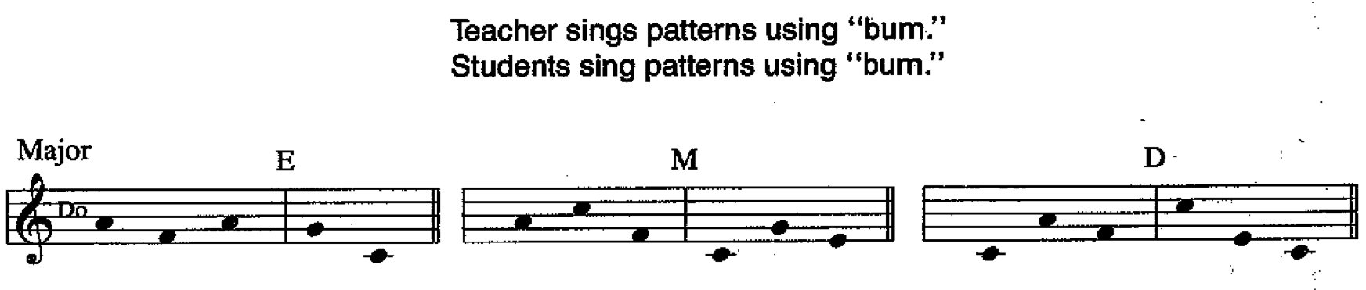

7A2: A/O Sing tonal sequence and class patterns in C major using “bum.” Fa do – so so | do la fa – do so do | do do fa – so do mi
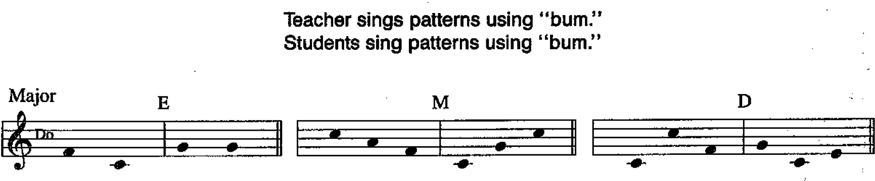

7B1: A/O Sing tonal sequence and class patterns in C major using “bum.” Re fa – mi do mi | la fa re – la mi la | fa la re – do la do
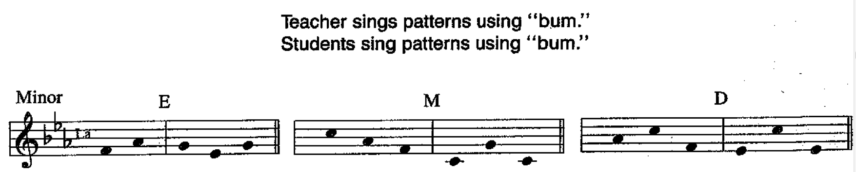

7B2: A/O Sing tonal sequence and class patterns in C minor using “bum.” Fa re la – la mi la | re fa la – do mi la | la fa la – do la do
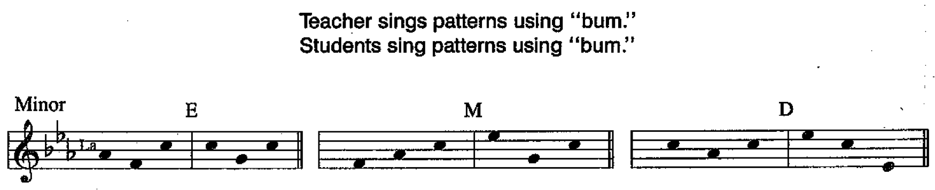

8A1: VA Sing tonal sequence and class patterns in C major using tonal syllables. la fa la – so do | la do fa – do so mi | do la fa – do mi do
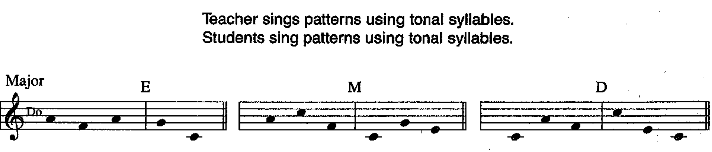

8A2: VA Sing tonal sequence and class patterns in C major using tonal syllables. Fa do – so so | do la fa – do mi do | do do fa – so do mi
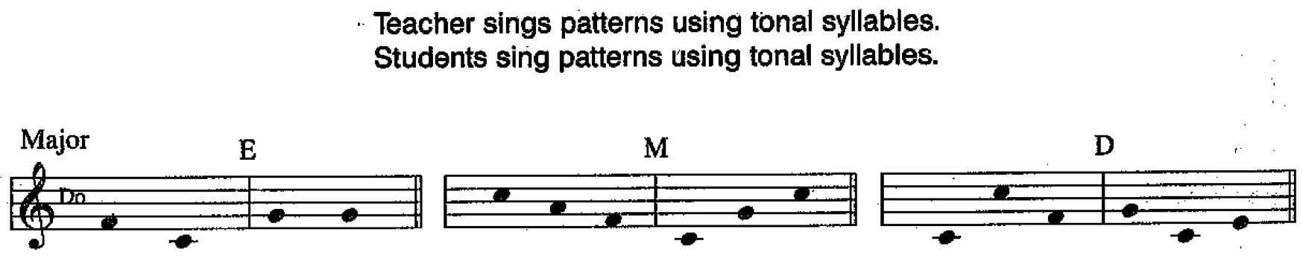

8B1: VA Sing tonal sequence and class patterns in C minor using tonal syllables. Re fa – mi do mi | la fa re – la mi la | fa la re – do la do
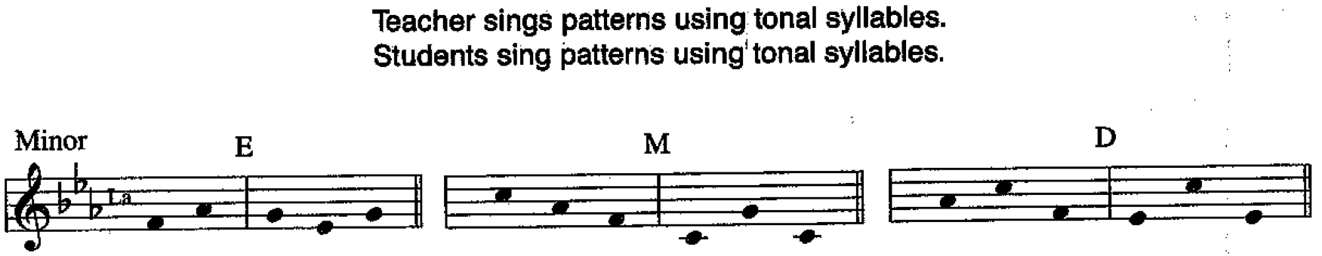

8B2: VA Sing tonal sequence and class patterns in C minor using tonal syllables. Fa re la – la mi la | re fa la – do mi la | la fa la – do la do
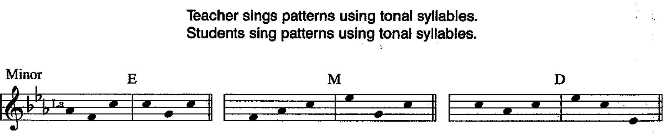

9A1: G-v Sing tonal sequence and class patterns in D major using “bum.” Do la – mi do | do la – mi so | do do la – ti so fa re
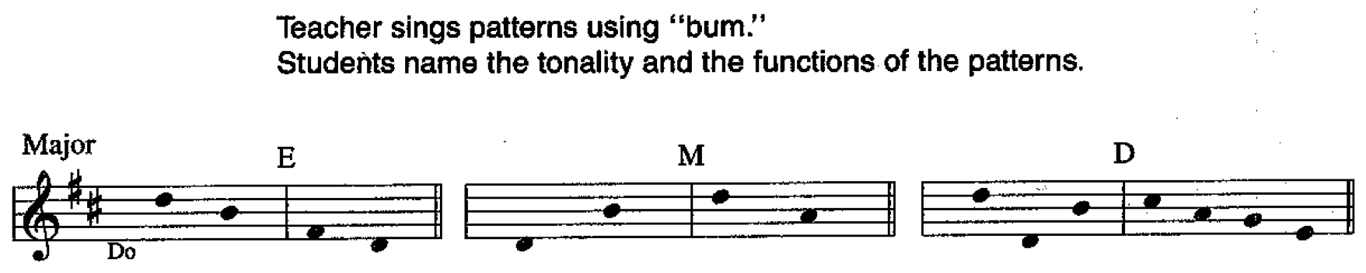

9A2: G-v Sing tonal sequence and class patterns in D major using “bum.” Do la do - fa do | do la do – do la do | do la fa – re ti
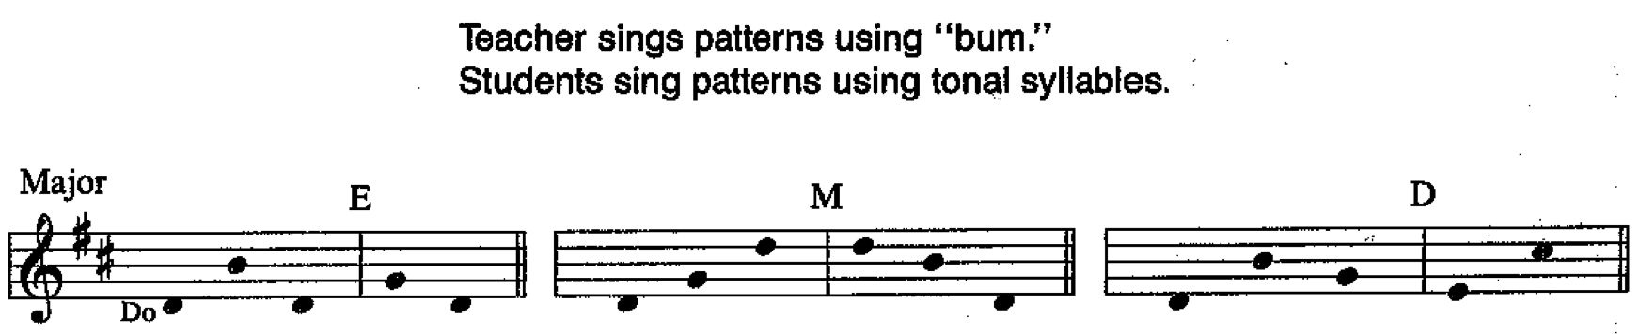

9A3: G-v Sing tonal sequence and class patterns in D major using “bum.” So do – re mi re | la do fa – fa la do | la fa – ti ti
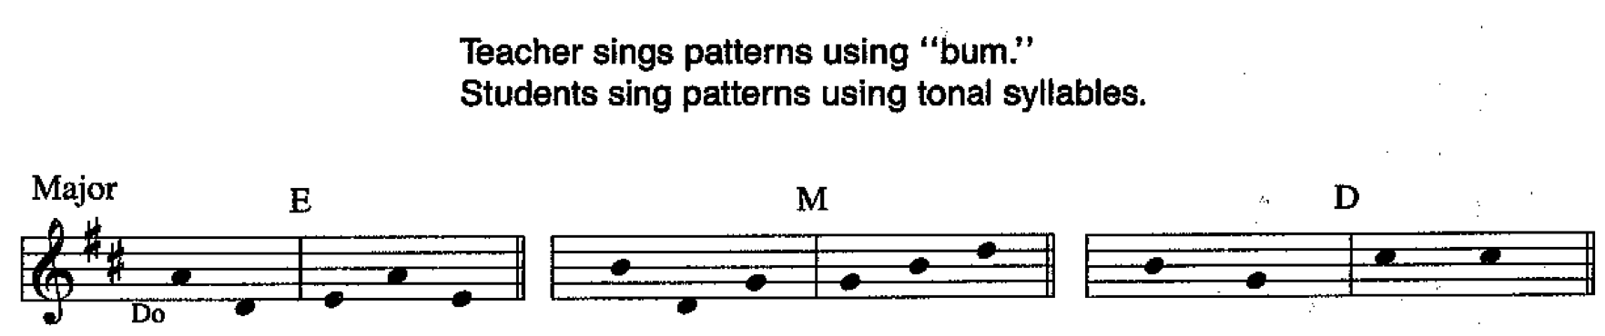

9B1: G-v Sing tonal sequence and class patterns in B minor using “bum.” Re la – mi la | la mi la - ti si mi | re fa la – ti mi si
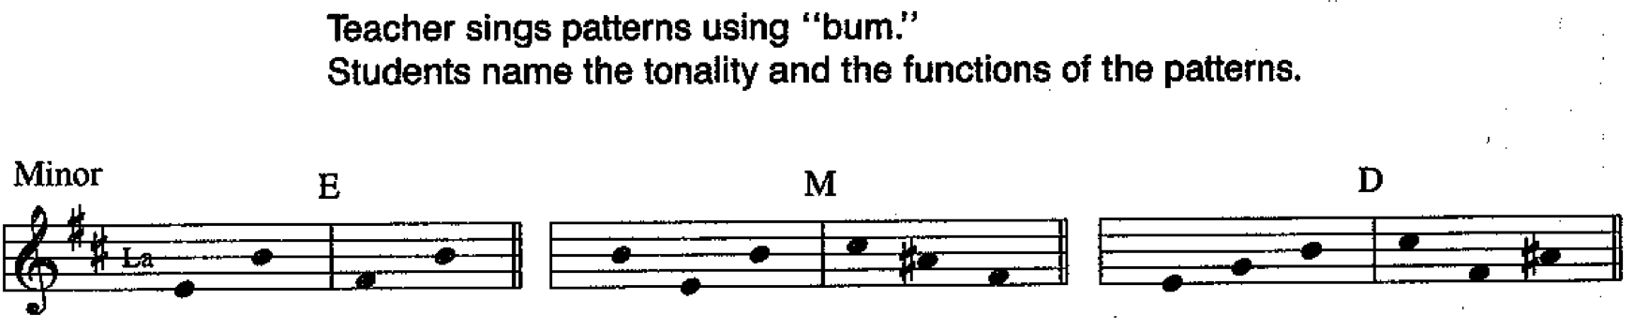

9B2: G-v Sing tonal sequence and class patterns in B minor using “bum.” Fa la – si ti si | la fa do – si mi si | fa la re – mi do la
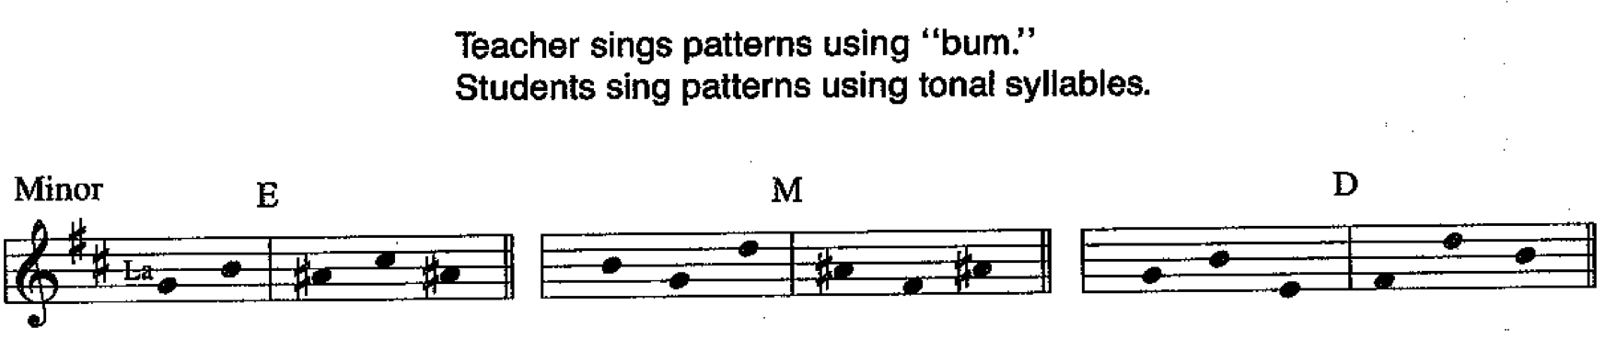

9B3: G-v Sing tonal sequence and class patterns in B minor using “bum.” La fa – mi ti | la re – re fa | fa do la – ti re mi si
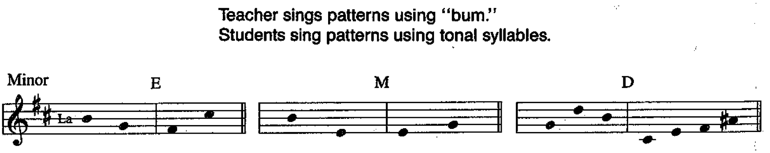

10A1: A/O Sing tonal sequence and class patterns in D major using “bum.” Do mi so – fa la fa | so mi do – so ti re | do mi so – re fa so ti
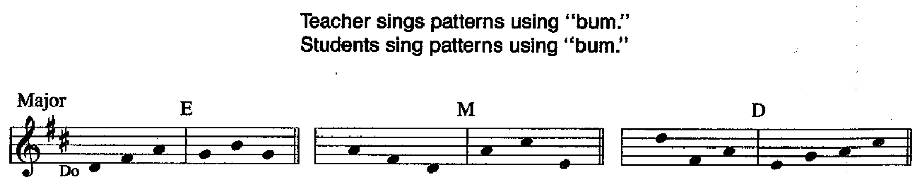

10A2: A/O Sing tonal sequence and class patterns in D major using “bum.” Re ti so – la do | fa la do -
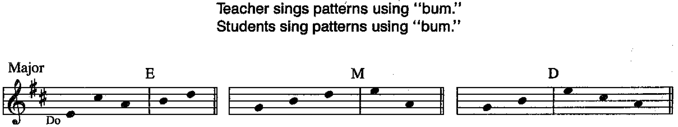

10B1: A/O Sing tonal sequence and class patterns in G minor using “bum.”
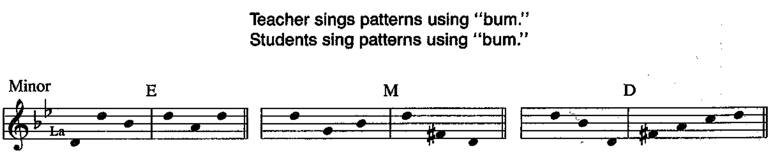
10B2: A/O Sing tonal sequence and class patterns in G minor using “bum.”
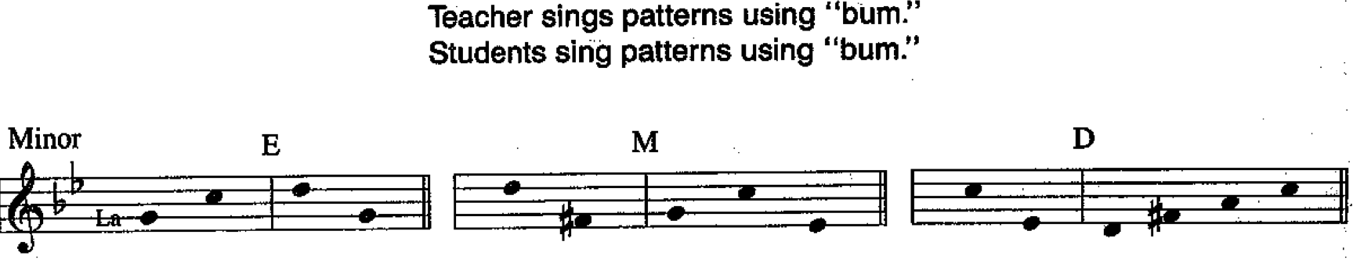

11A1: VA Sing tonal sequence and class patterns in D major using tonal syllables.
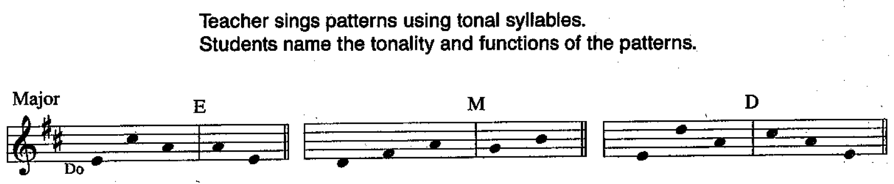

11A2: VA Sing tonal sequence and class patterns in B minor using tonal syllables.
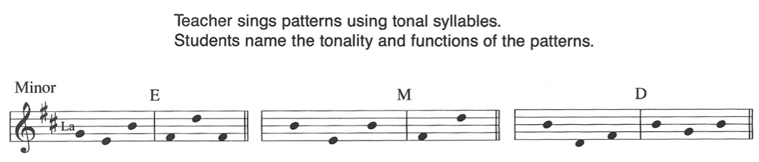

11B1: VA Sing tonal sequence and class patterns in D major using tonal syllables.
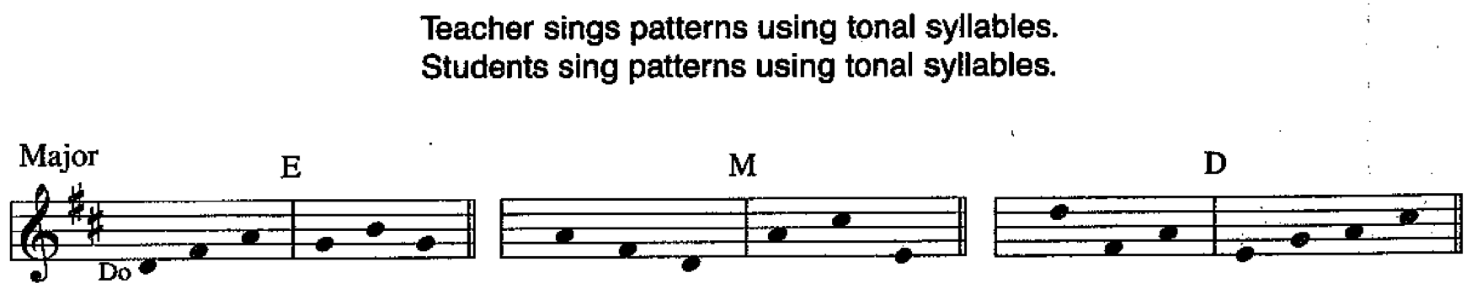

11B2: VA Sing tonal sequence and class patterns in D major using tonal syllables.
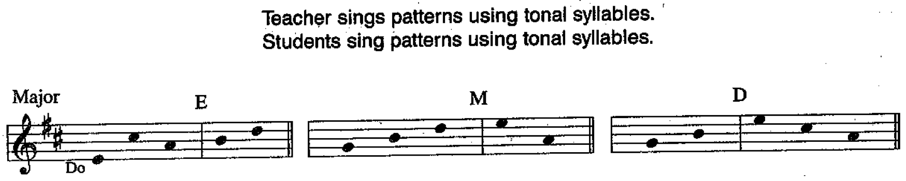
11C1: VA Sing tonal sequence and class patterns in G minor using tonal syllables.
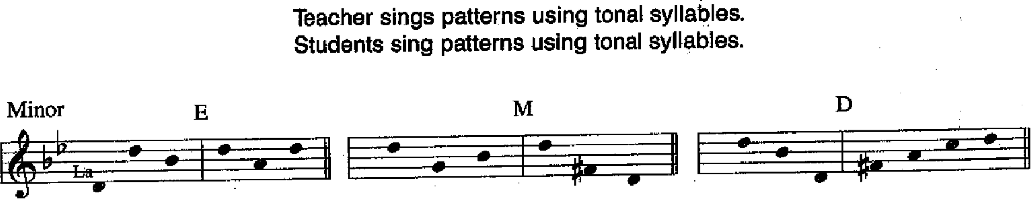

11C2: VA Sing tonal sequence and class patterns in G minor using tonal syllables.
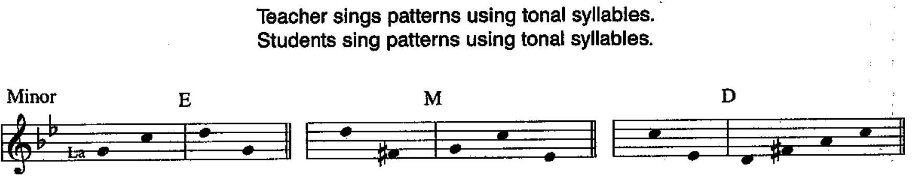

12A1: SA-r Sing tonal sequence and dialogue patterns in D major using tonal syllables. Do not sing class patterns.
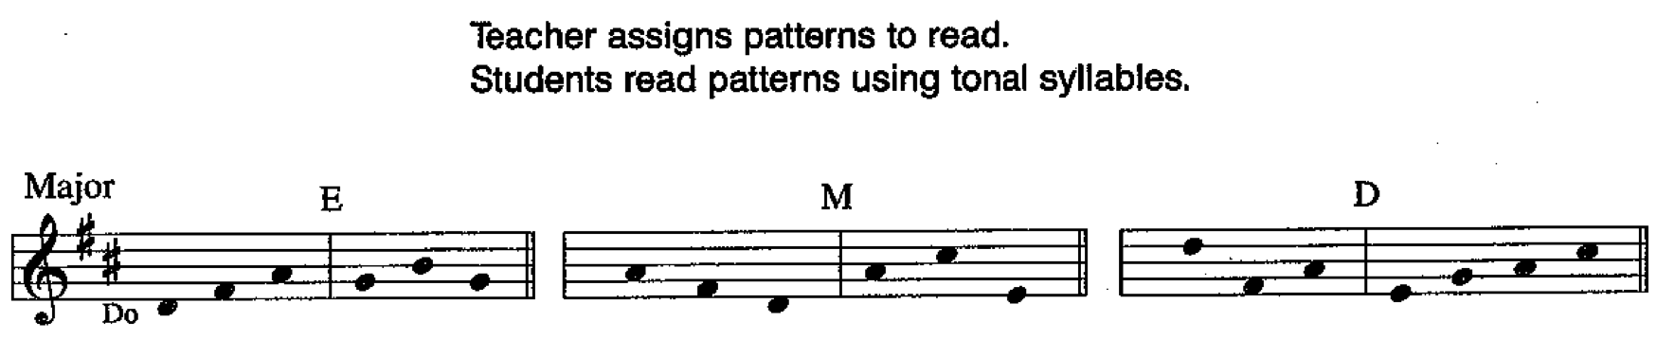

12A2: SA-r Sing tonal sequence and dialogue patterns in D major using tonal syllables. Do not sing class patterns.
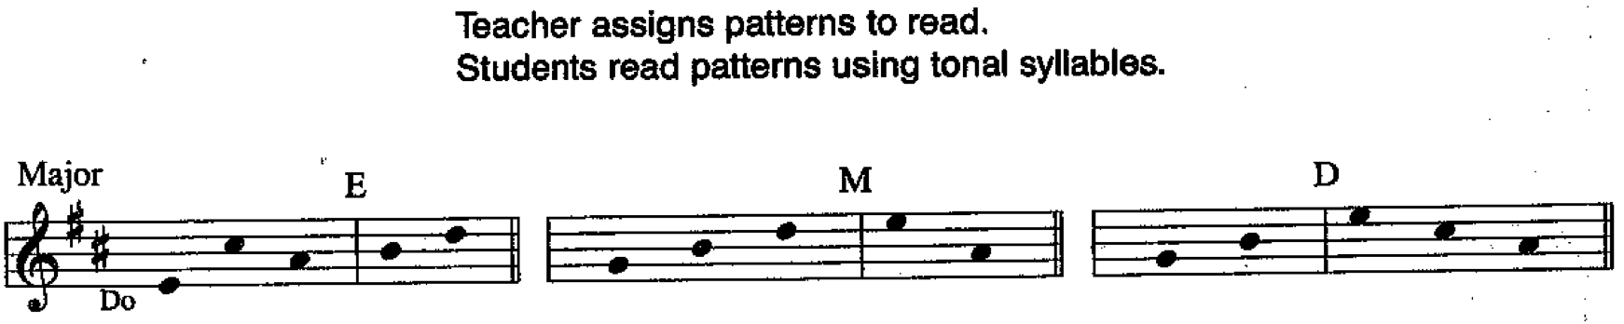

12B1: SA-r Sing tonal sequence and dialogue patterns in G minor using tonal syllables. Do not sing class patterns.
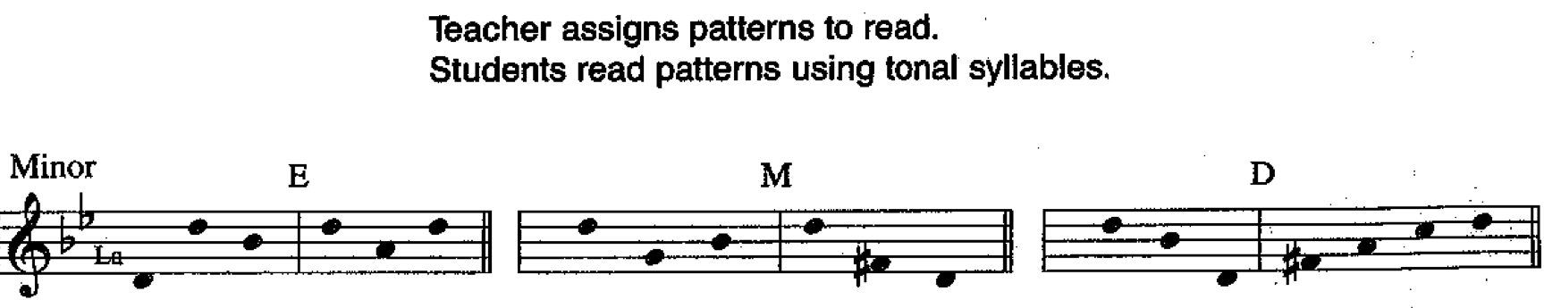

12B2: SA-r Sing tonal sequence and dialogue patterns in G minor using tonal syllables. Do not sing class patterns.
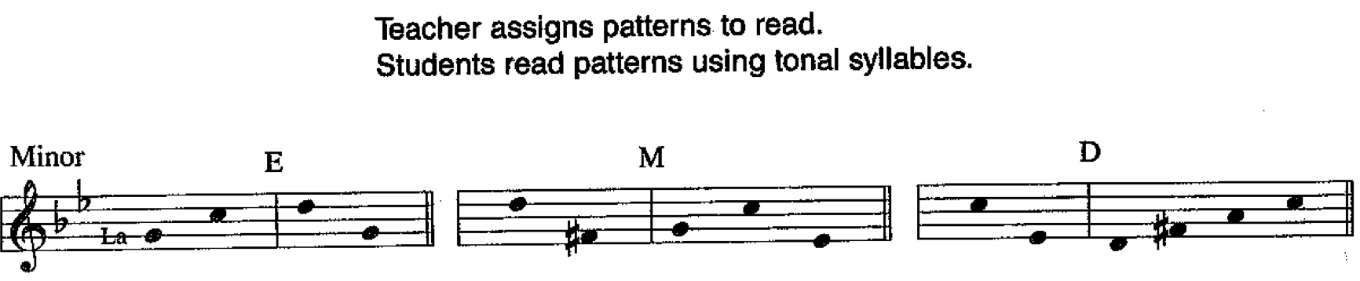

13A1: SA-w Sing tonal sequence and dialogue patterns in D major using tonal syllables. Do not sing class patterns.
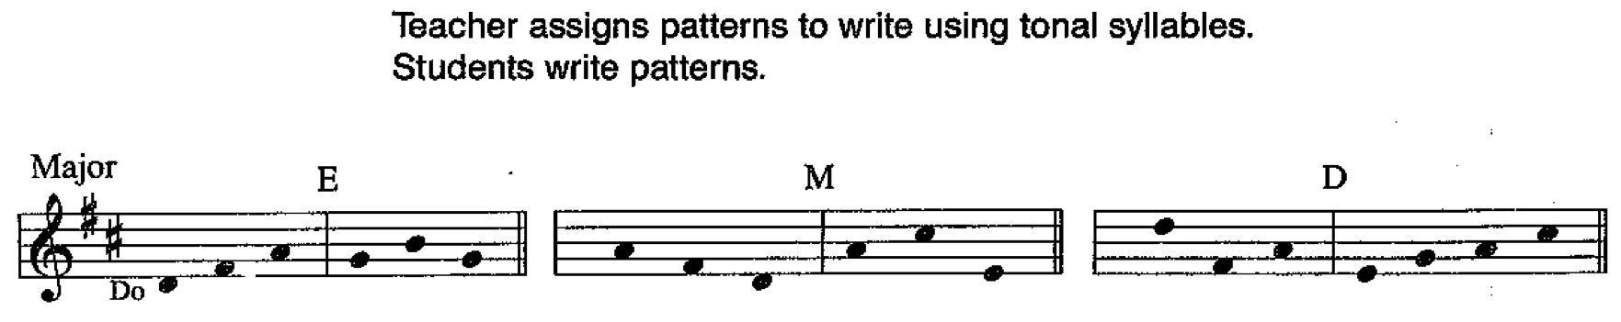

13A2: SA-w Sing tonal sequence and dialogue patterns in D major using tonal syllables. Do not sing class patterns.
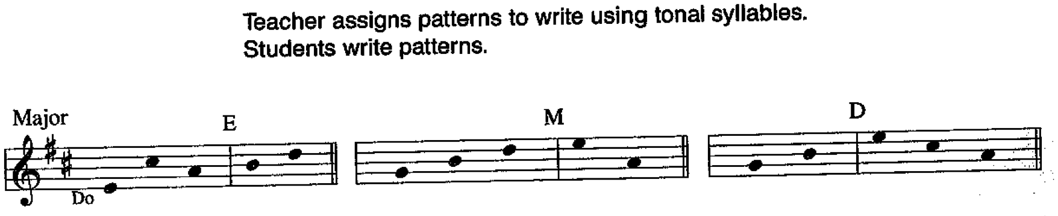

13B1: SA-w Sing tonal sequence and dialogue patterns in G minor using tonal syllables. Do not sing class patterns.
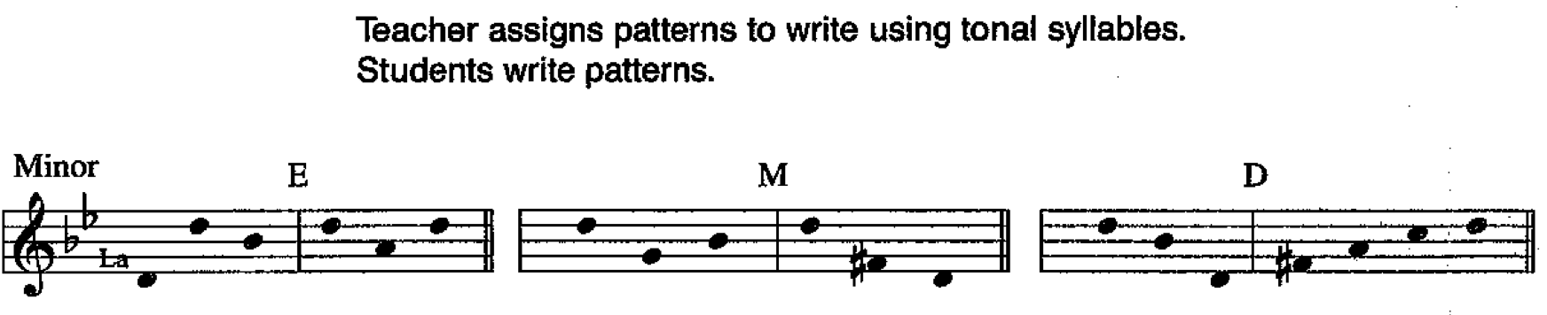

13B2: SA-w Sing tonal sequence and dialogue patterns in G minor using tonal syllables. Do not sing class patterns.
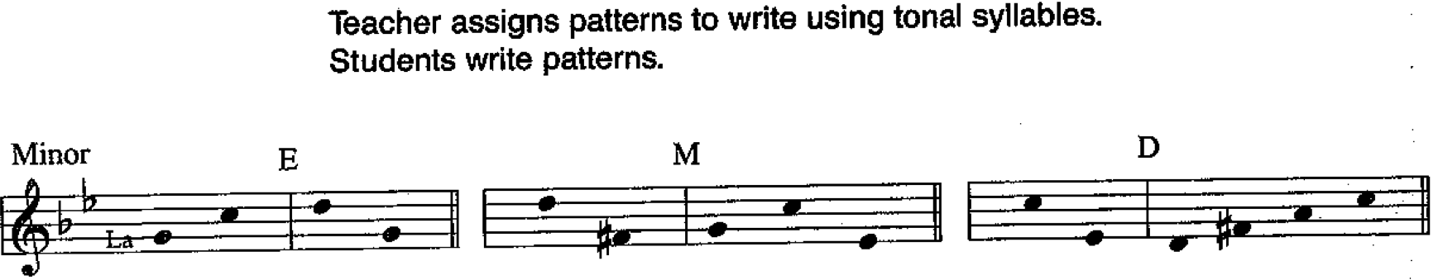

14A1: C/I-v Sing tonal sequence and class patterns in C major using tonal syllables.
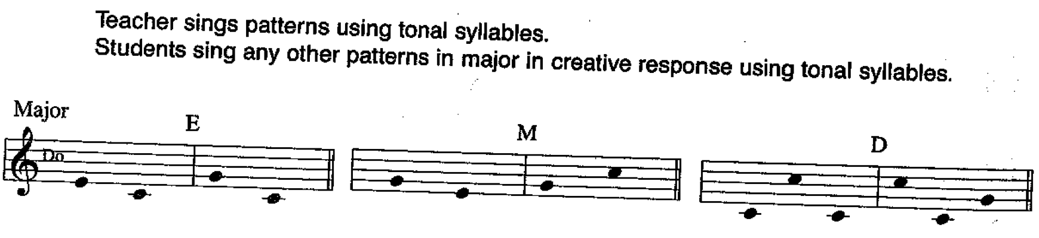

14A2: C/I-v Sing tonal sequence and class patterns in A minor using tonal syllables.
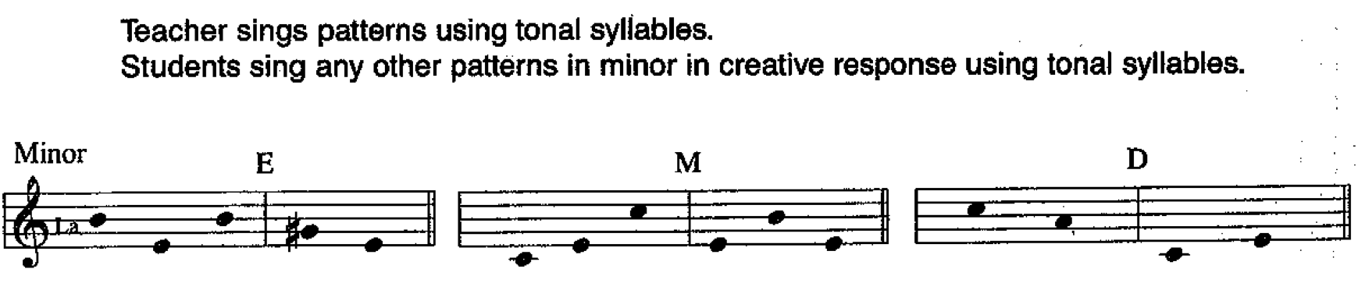

14B1: C/I-v Sing tonal sequence and class patterns in C major using tonal syllables.
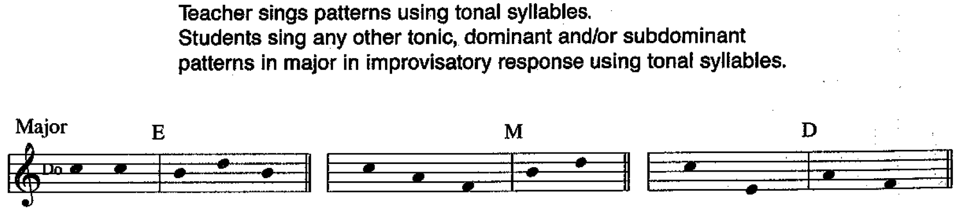

14B2: C/I-v Sing tonal sequence and class patterns in A minor using tonal syllables.
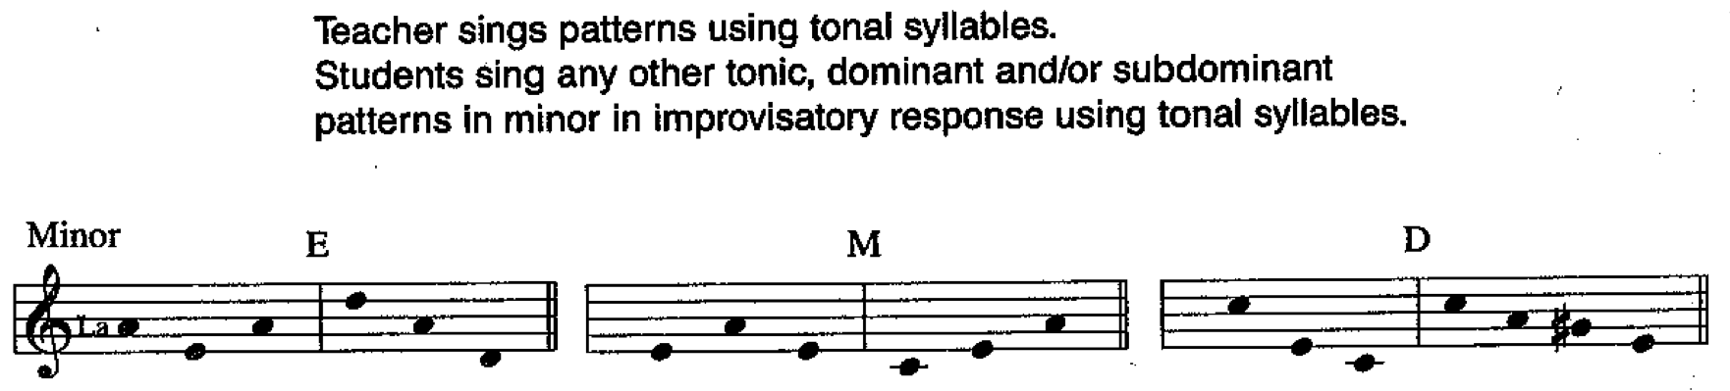

15A1: A/O Sing tonal sequence and class patterns in F mixolydian using “bum.”
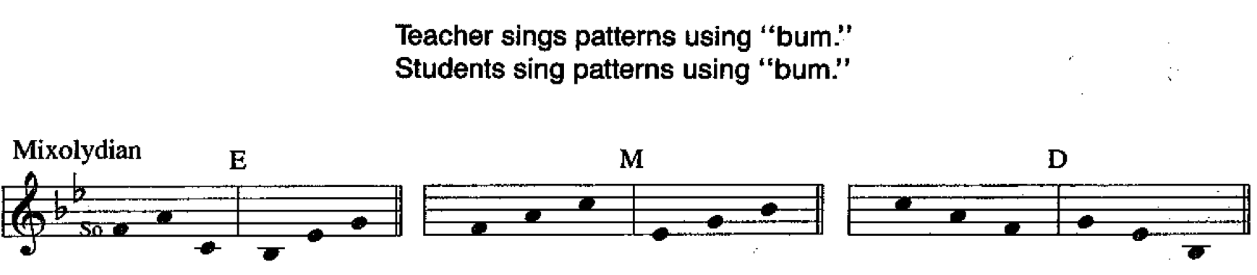

15A2: A/O Sing tonal sequence and class patterns in D dorian using “bum.”
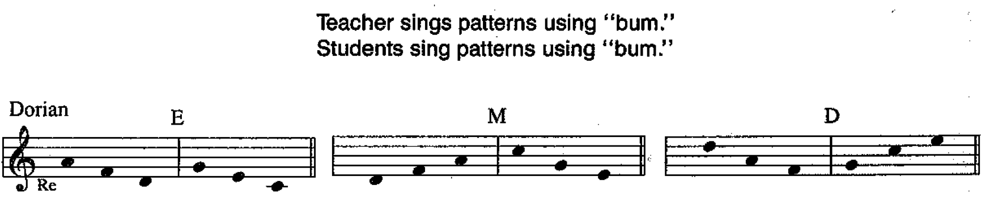
15B1: A/O Sing tonal sequence and class patterns in F mixolydian using “bum.”
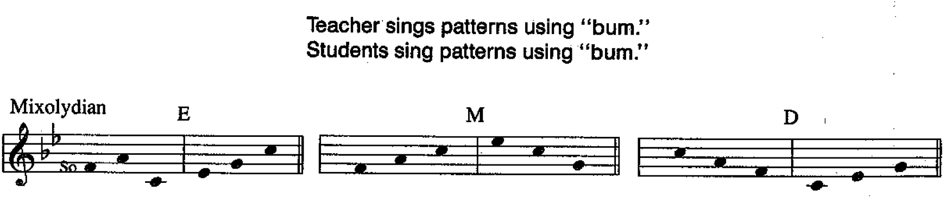
15B2: A/O Sing tonal sequence and class patterns in D dorian using “bum.”
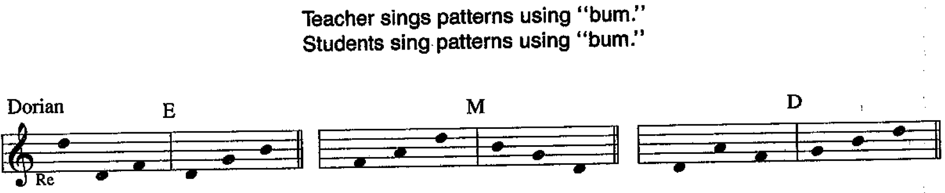

16A1: VA Sing tonal sequence and class patterns in D mixolydian using tonal syllables.
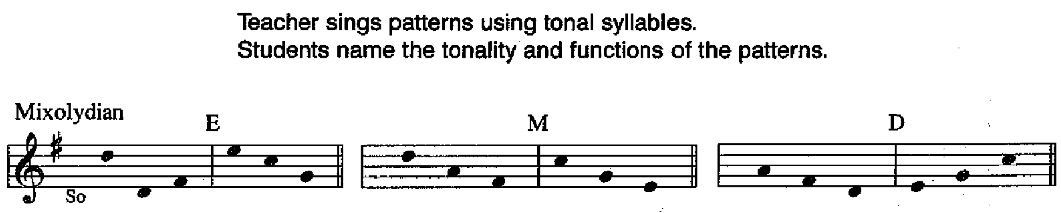

16A2: VA Sing tonal sequence and class patterns in D dorian using tonal syllables.
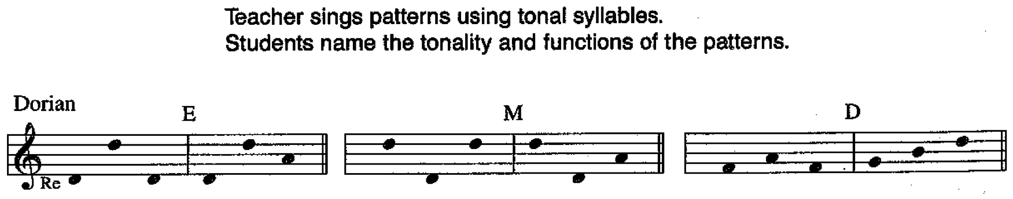

16B1: VA Sing tonal sequence and class patterns in F mixolydian using tonal syllables.
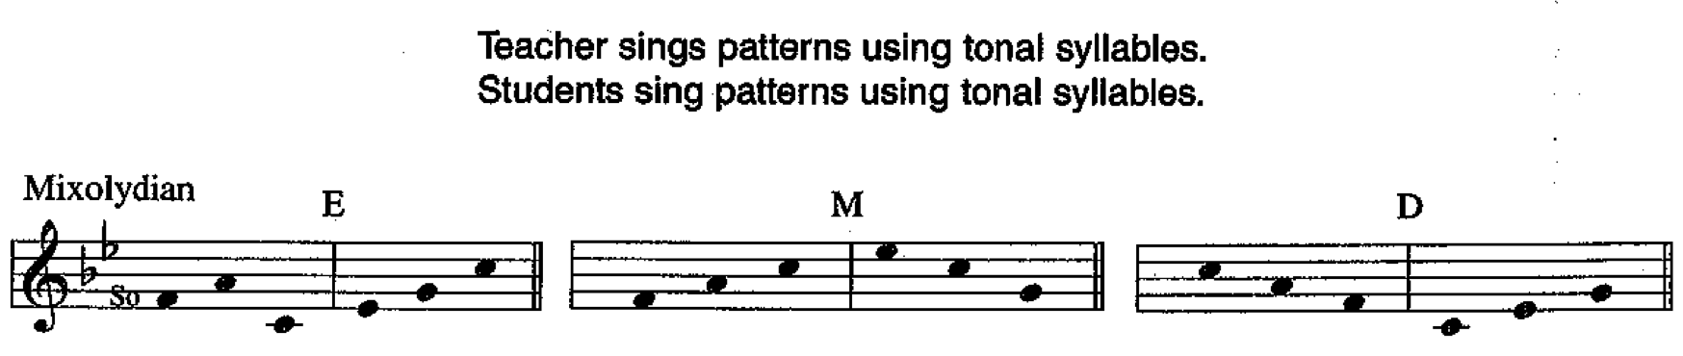

16B2: VA Sing tonal sequence and class patterns in D dorian using tonal syllables.
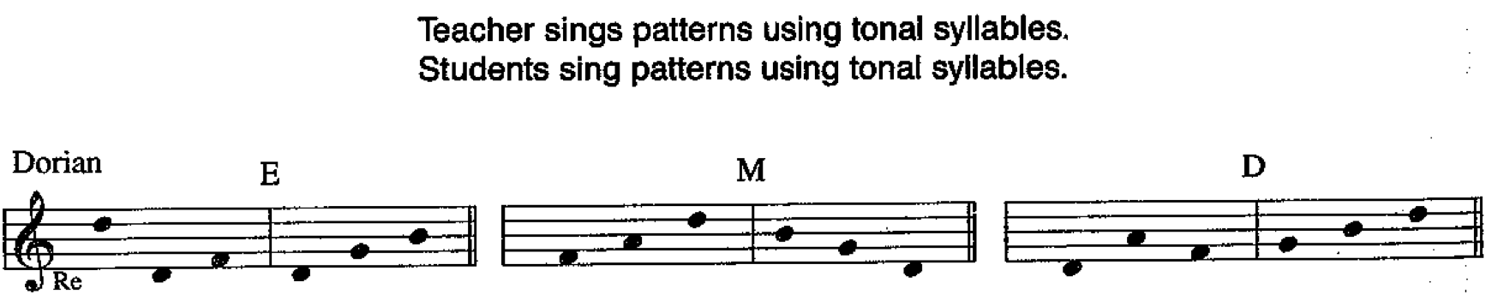

16C1: VA Sing tonal sequence and class patterns in F mixolydian using tonal syllables.
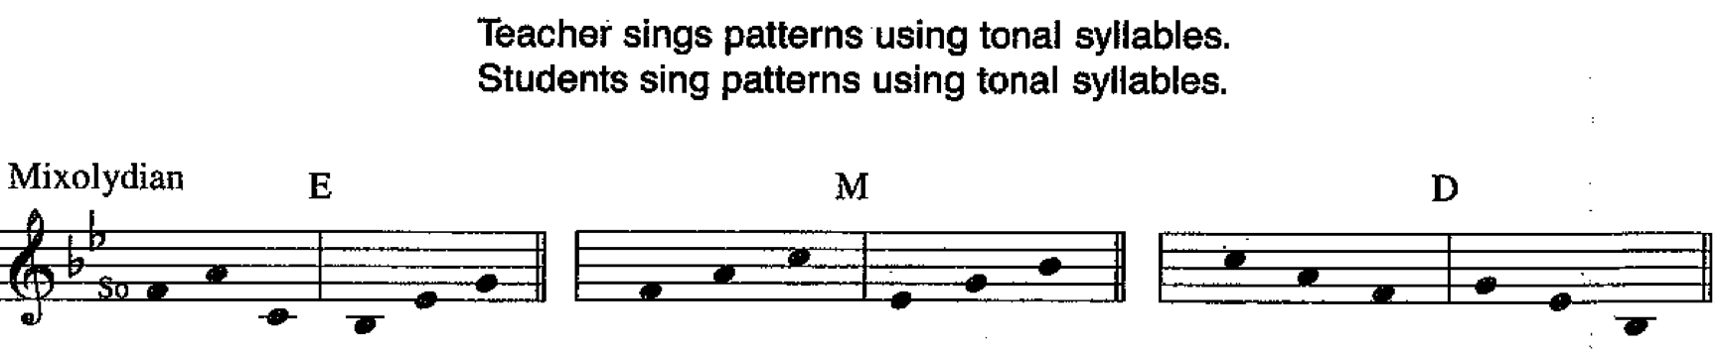

16C2: VA Sing tonal sequence and class patterns in D dorian using tonal syllables.
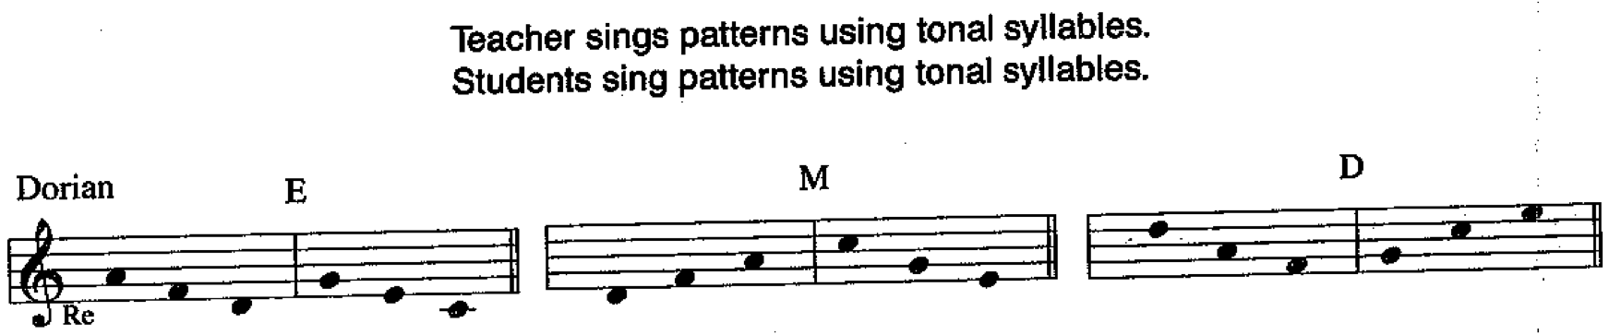

17A1: PS Do not sing tonal sequence or class patterns.
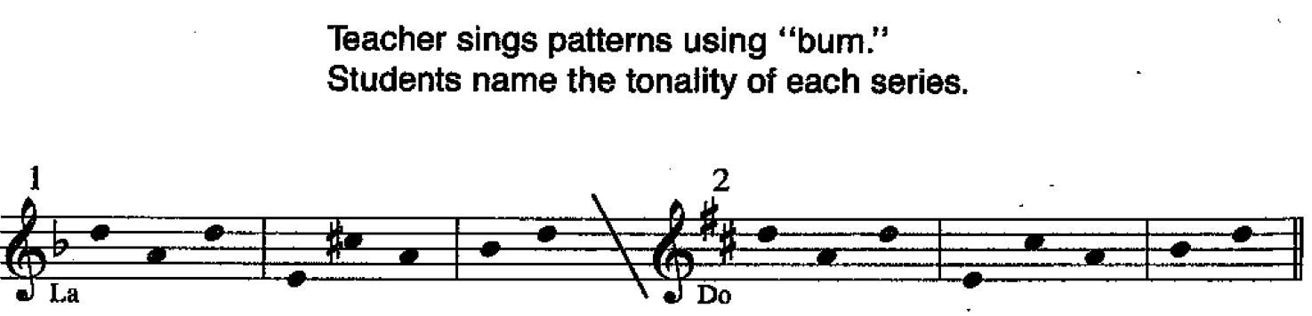

17A2: PS Do not sing tonal sequence or class patterns.
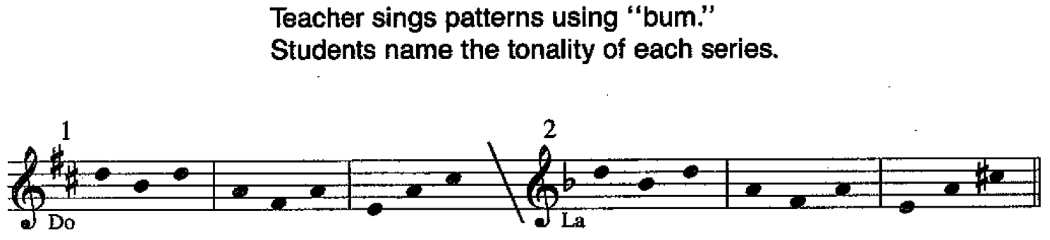

18A1: G-s Sing tonal sequence and dialogue patterns in F major using tonal syllables. Do not sing class patterns.
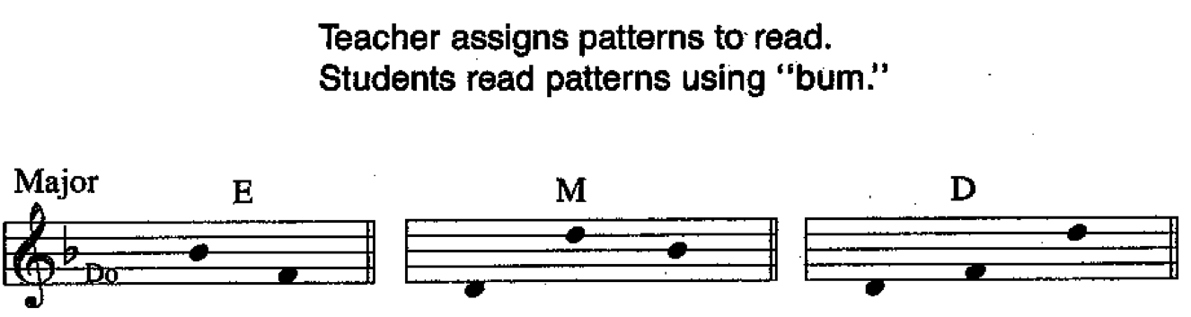

18A2: G-s Sing tonal sequence and dialogue patterns in F major using tonal syllables. Do not sing class patterns.
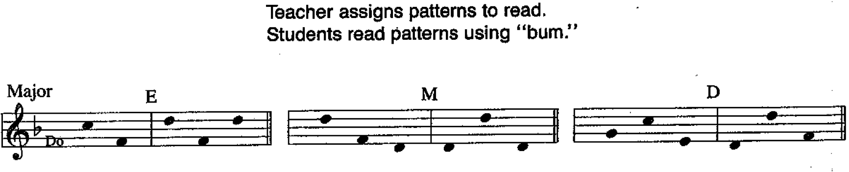

18A3: G-s Sing tonal sequence and dialogue patterns in F major using tonal syllables. Do not sing class patterns. Do la do – ti re ti | la fa la – la do la | la la fa – mi do so
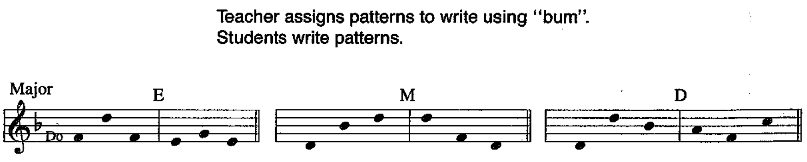

18B1: G-s Sing tonal sequence and dialogue patterns in C minor using tonal syllables. Do not sing class patterns.
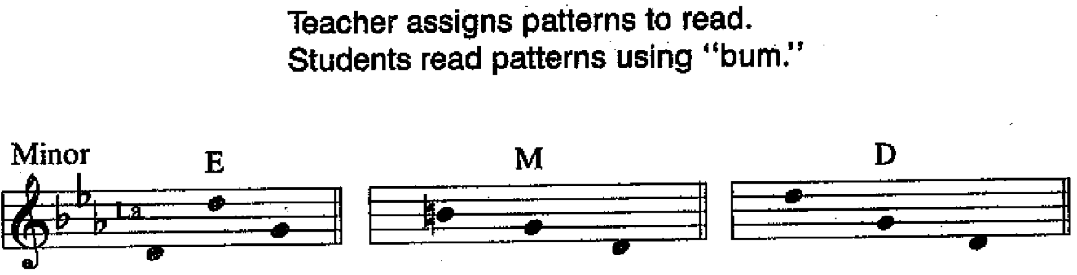

18B2: G-s Sing tonal sequence and dialogue patterns in C minor using tonal syllables. Do not sing class patterns.
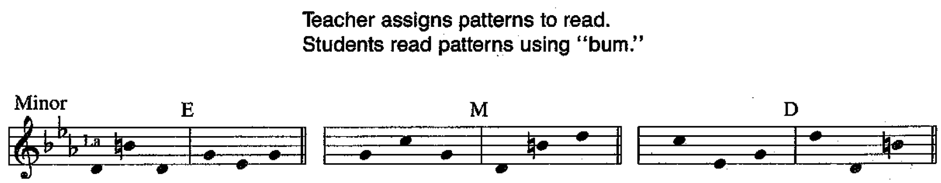

18B3: G-s Sing tonal sequence and dialogue patterns in C minor using tonal syllables. Do not sing class patterns.
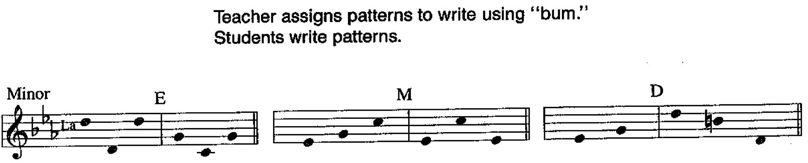

19A1: CS-r Sing tonal sequence and dialogue patterns in Eb major using tonal syllables. Do not sing class patterns.
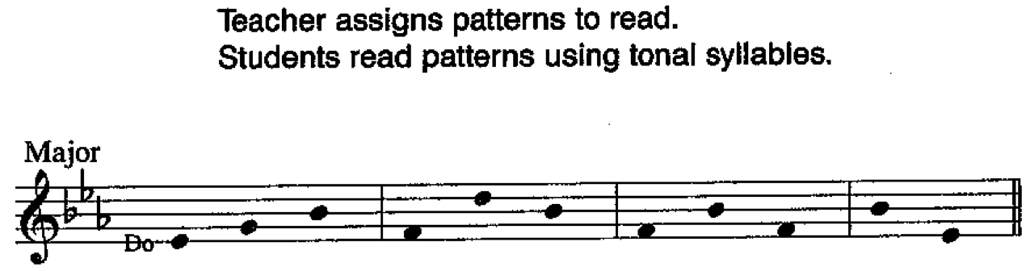

19A2: CS-r Sing tonal sequence and dialogue patterns in Eb major using tonal syllables. Do not sing class patterns.
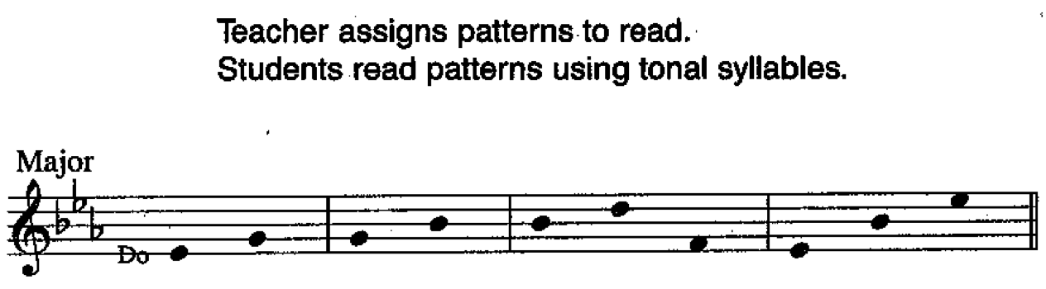

19B1: CS-r Sing tonal sequence and dialogue patterns in B minor using tonal syllables. Do not sing class patterns.
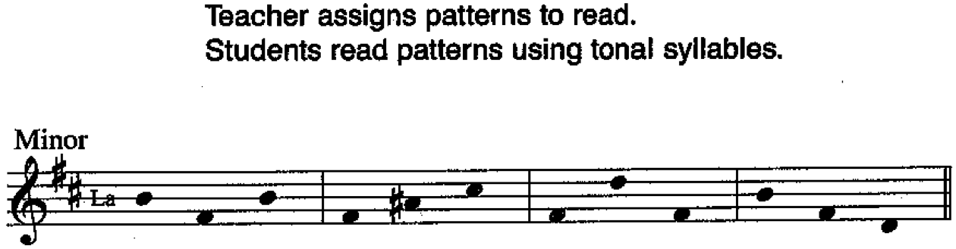

19B2: CS-r Sing tonal sequence and dialogue patterns in B minor using tonal syllables. Do not sing class patterns.
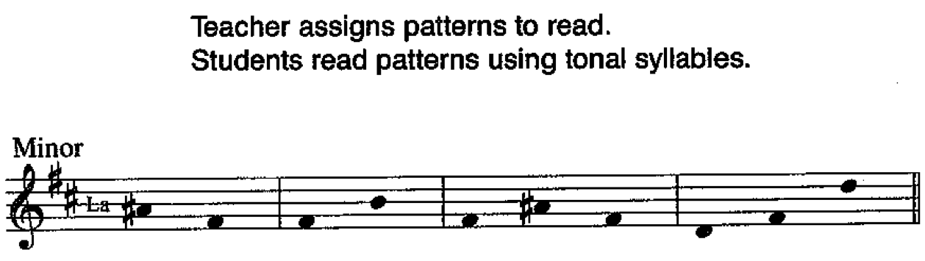

20A1: PS Do not sing tonal sequence or class patterns.
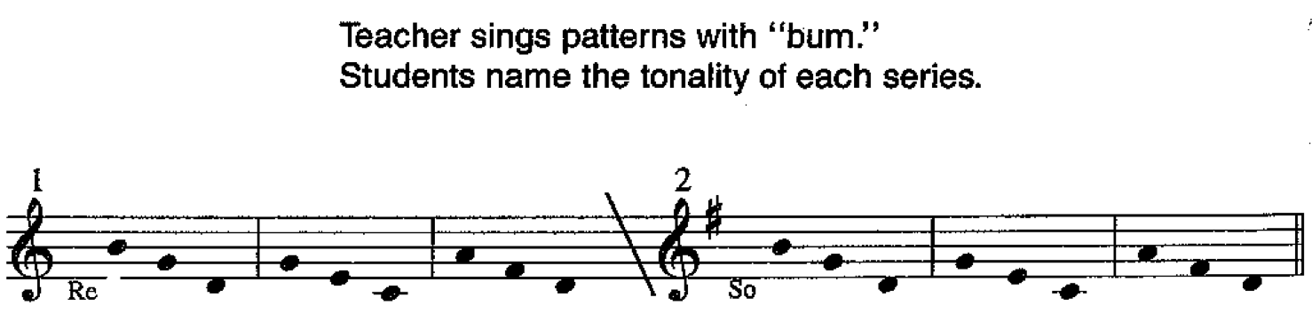

20A2: PS Do not sing tonal sequence or class patterns.
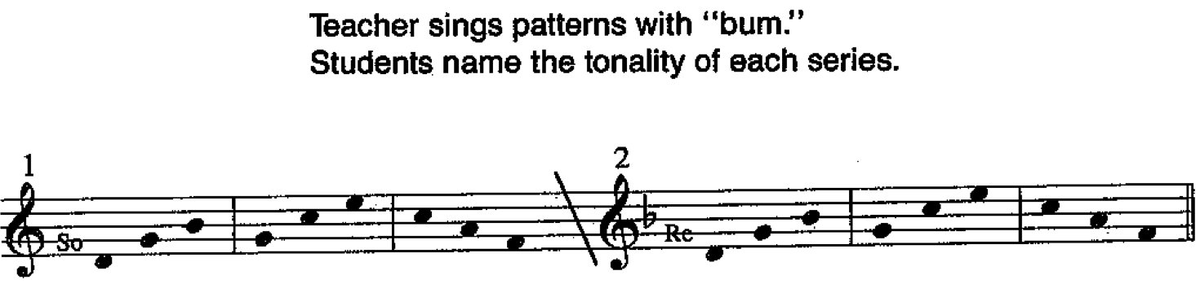

21A1: SA-r Sing tonal sequence and dialogue patterns in F mixolydian using tonal syllables. Do not sing class patterns.
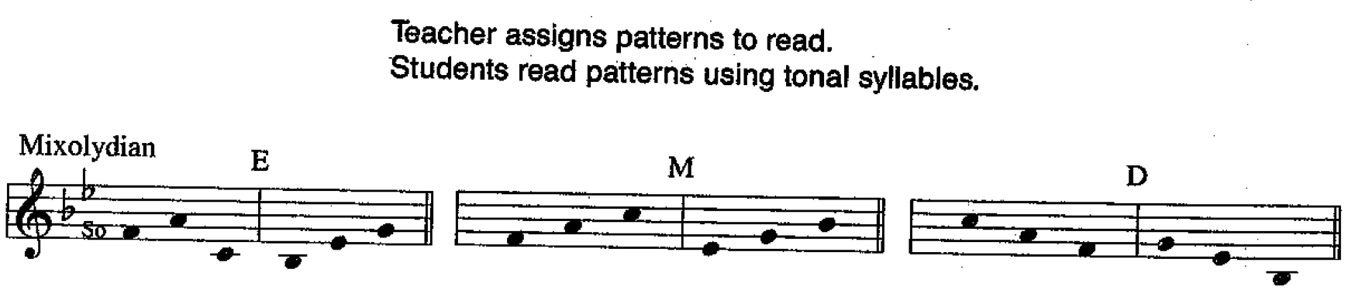

21A2: SA-r Sing tonal sequence and dialogue patterns in F mixolydian using tonal syllables. Do not sing class patterns.
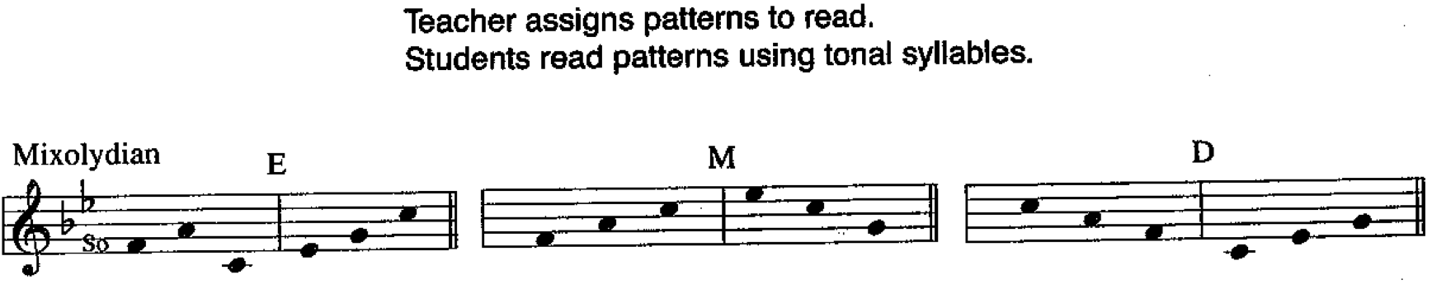

21B1: SA-r Sing tonal sequence and dialogue patterns in D dorian using tonal syllables. Do not sing class patterns.
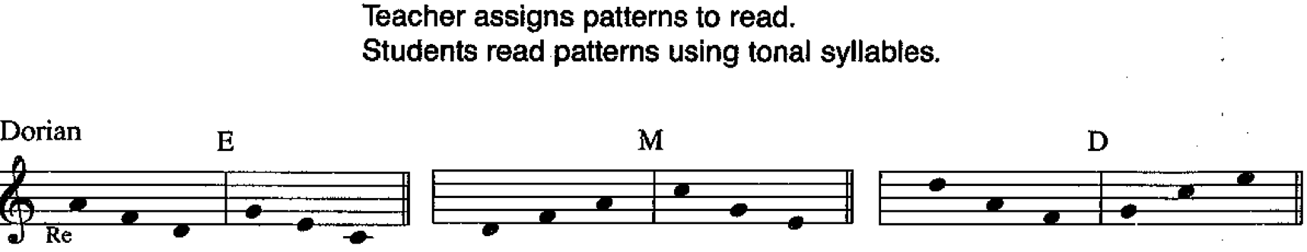

21B2: SA-r Sing tonal sequence and dialogue patterns in D dorian using tonal syllables. Do not sing class patterns.
